**Password Based Circuit Breaker**

**INTRODUCTION**

To increase the security levels of the prison, one day the jailer of the prison thought to design a system,through which he can access the prison cells , through a password only which he knows. Now thinking you are the jailer, design a system (circuit) through which only you can open and close the prison cellwith a unique password assigned to each prison cell

. 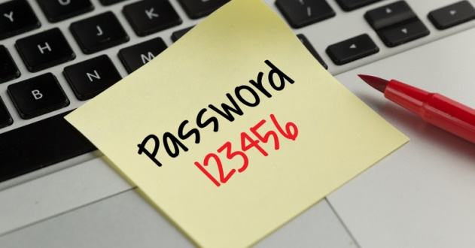

**PROBLEM STATEMENT**

Design a System using Microcontroller Programming and Circuit Breaker , a Password based system which only you can open with that unique passwords.

**Team Size**

* A team may consist of at least 2 members and should not exceed more than 4 members.
* One team has to make only one prototype. Participants cannot be a part of more than one team of this event.

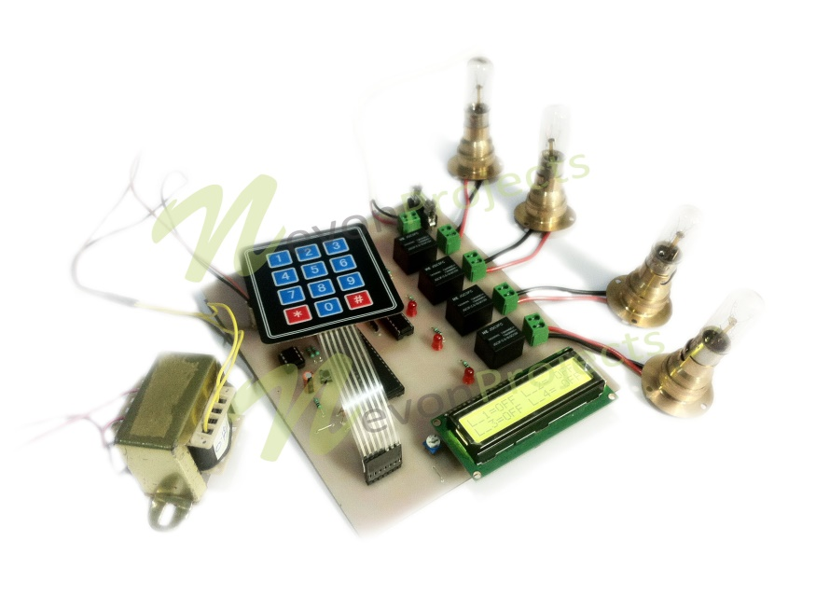

**Rules**

* Components will be issued to team prior to the time of the event according to the abstract submitted by the team.
* Inter batch team will be awarded few extra points.
* Participants should strictly meet the deadline of the event. No extra time will be given after the event.
* Abstract should be submitted to Event Co-coordinators.

Specifications

* First stage of the event is abstract submission which you should submit to the event coordinator prior to the event so that the resources could be issued at time.
* Abstract should be clear and precise and should present a clear idea how team intends to solve the problem
* Abstract should have a circuit diagram with the logic that you intend to build.
* Any other extra feature implemented in the design will gain you some points
* Teams will not get any extra time for practice, testing or calibrations on the main arena during the event.

**Judging Criteria**

• Your Circuit should be clean and wires shouldn’t be hanging around (Extra Points for clean circuit).

• The System should be easily simulated.

• You will be using pic microcontroller, you should know how does it works

• If two teams using same Code will be disqualified.

In general,the decision of the organizers will be final and binding in all circumstances. No more changes will be encouraged, thus holding the full authority to change any of the above rules as per circumstances

**Resources**

1.  http://www.circuitstoday.com/introduction-to-pic-16f877  
2.  https://en.wikipedia.org/wiki/PIC_microcontroller

**Contacts**

**Chirayu Parashar**

**+91 7073400151** [**parashar.1@iitj.ac.in**](mailto:parashar.1@iitj.ac.in)

**Archit Sharma**

**+91 9672163206 sharma.2@iitj.ac.in**